# B.Eng in Automation and Robotics

# Instrumentation and Control Lab 1

# 5th of February 2021

## Student: Cian Baynes

## I.D. No.: 10016450

## Summary

This is the report for Lab 3 of the Instruments and Control Module which was run on February 5th 2021. The report describes the tasks that were caried out in the lab and the results from the tasks. The lab was and lab sensors, calibration and analysis.

The image below shows the wiring of the depth sensor. The orange wire was wired into the A0 port on the Arduino, the red wire was wired to the 5V port on the Arduino and the black wire was wired to one of the ground ports on the Arduino.

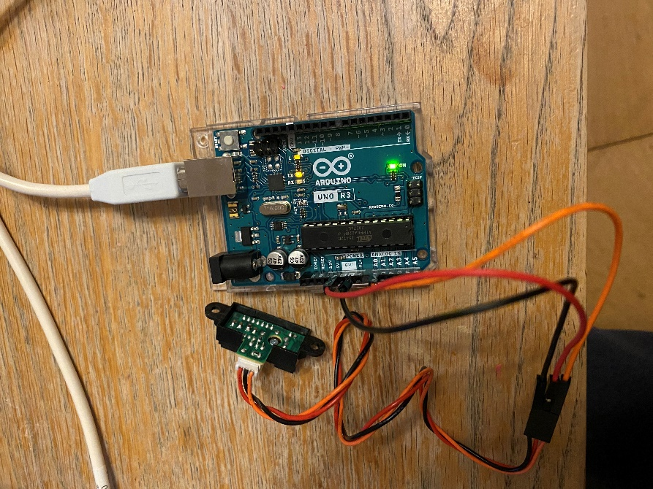

Figure - Wiring of the sensor.

Below is an image showing the depth sensor and a ruler to read and record the voltages at different distances to calibrate the depth sensor. This is the basic setup for the experiment.

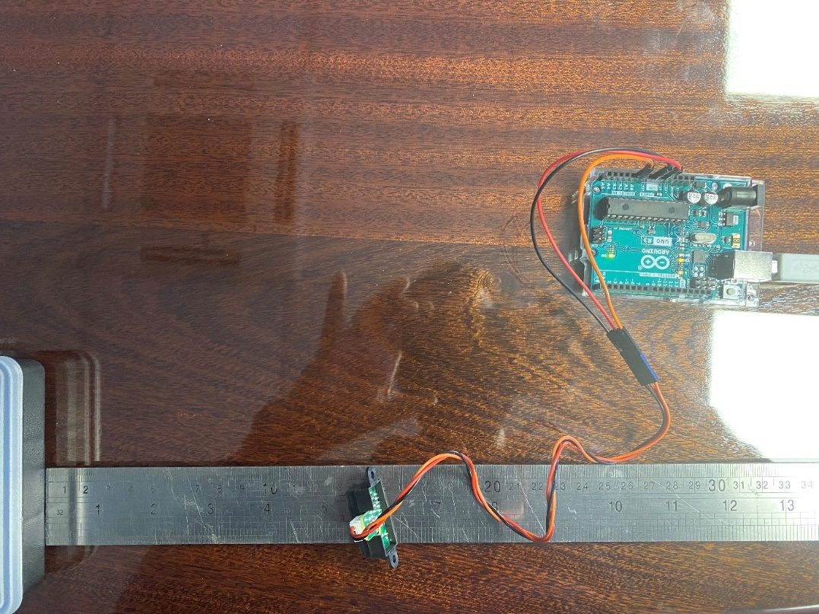

Figure - Image of experiment set up with ruler, sensor and Arduino microcontroller

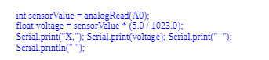

Figure - Arduino code used to read and record the voltage for the distances used.

The Arduino code above was used to record the voltage at the distances, the distances started at 5mm and increased in 5mm increments to 80mm. The voltage was recorded using the serial monitor function on the Arduino software.

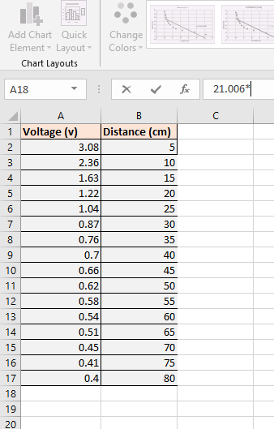

Figure – Excel sheet showing voltage value when measured from sensor using ruler

The recorded values for the distances were then entered into the supplied excel sheet and the equation for the line was generated. This line is the regression line which was used for the sensor calibration. The equation was y=-21.006x + 58.543. The line graphed against the points that were recorded is shown in figure 5.

Figure - Graph of results from sensor readings

This equation was used in the Arduino code so that it was possible to output a measurement from the voltage readings from the sensor. The Arduino code including the equation for the line are shown in figure 6. Where the voltage is x and the distance is y from the equation.

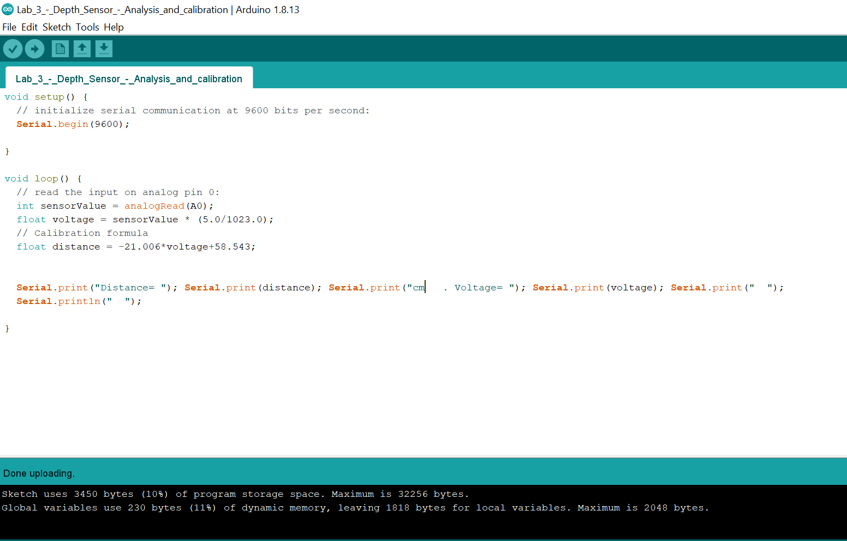

Figure - Arduino code with linear regression line included

I also modified output for the serial monitor so that the distance and the corresponding voltage is outputted. An image of the serial monitor is shown in figure 7.

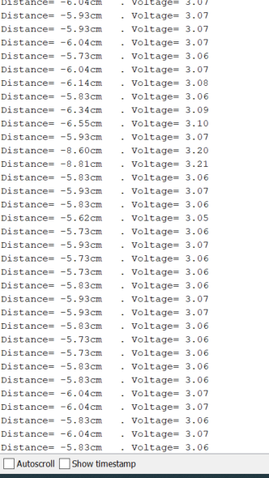

Figure – Serial monitor output of the distance and the voltage

Once the equation for the line was inserted the actual distance set to 5cm the program outputs a distance of -6cm, however the voltages match with my original reading of 3.06. The reason for this is that I am using a straight-line graph. Figures 8 and 9 show the result when the distance is 10cm and 25cm. What is noticeable is that the result at 10cm is reasonably accurate, this is because the line passes very close to a recorded point at this stage and the result would be very accurate and is expected based on the graph. The line is basically crossing the graph at this point if I was using a curved line.

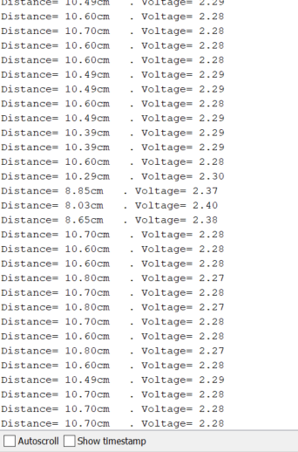

Figure - Actual distance is 10cm, the program is reading approximately 10cm. This concurs with the graph as the line of the graph crosses through this point and it is the only time for this that the distance will be correct. The voltages match as is expected.

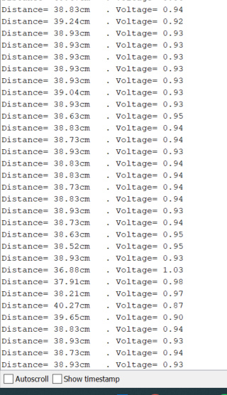

Figure - Actual distance is 25cm. The distances again don't match due to the nature of the graph and the expected accuracy. The voltages match.

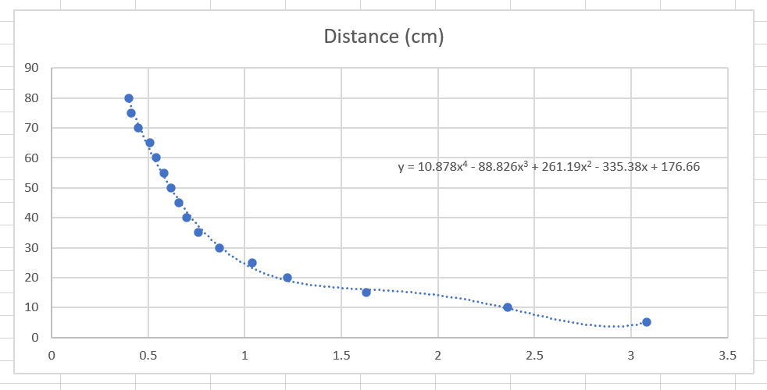

Figure - Equation for a curved line should give a much more accurate result in terms of the distance matching the voltages.

Figure 10 shows a curved line through the points and the equation for this curved line. Using this equation in the Arduino code would yield much more accurate results from the sensor. The Arduino code below shows this equation inserted to give a more accurate result from the sensor.

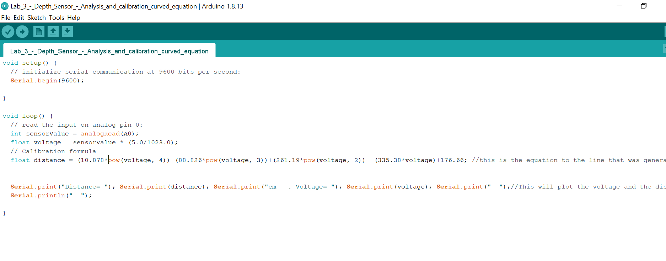

Figure - Arduino code for regression equation of a curved line to give more accurate measurements.